Start of sprint

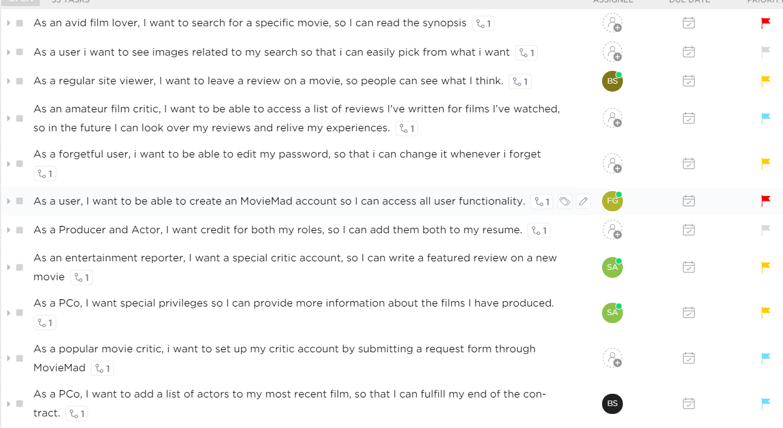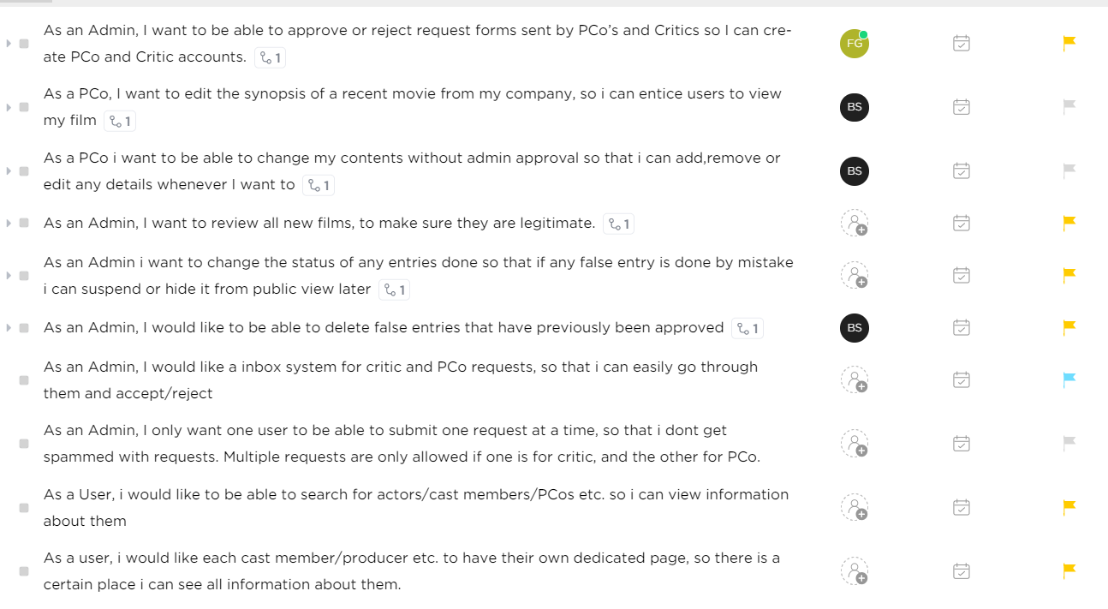

Midway 1





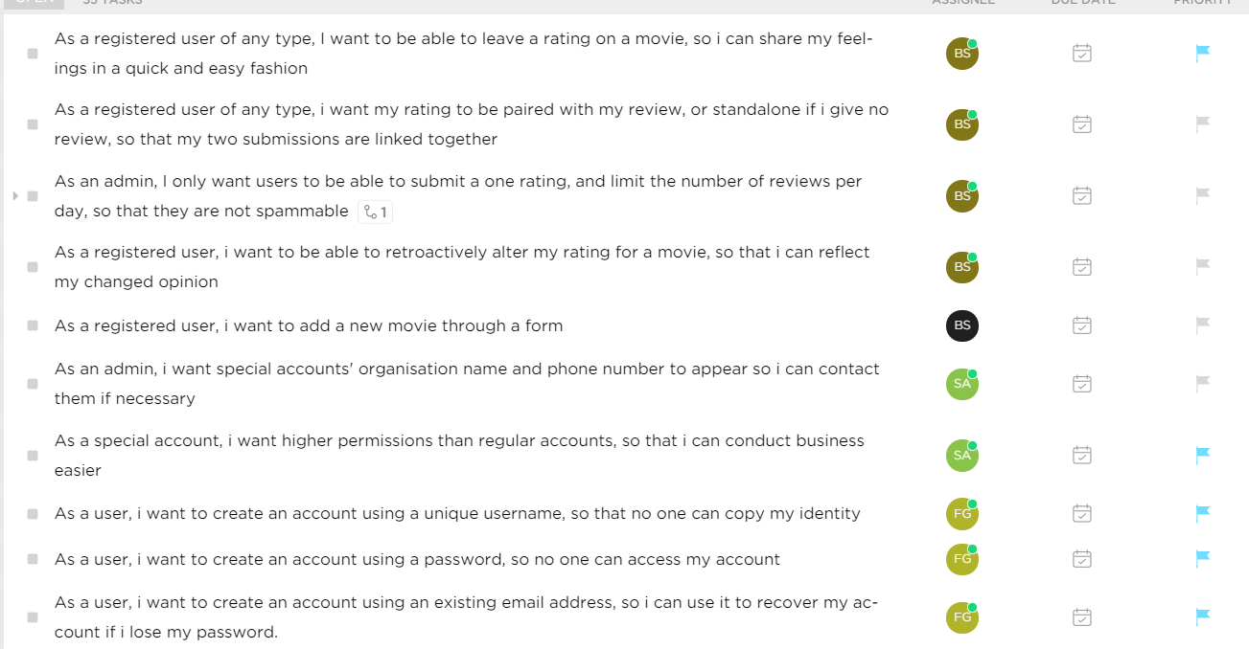

Midway 2

First 11 stories – Fraser, due date 23/05/2021

Next 10 stories – Showvic, due date 23/05/2021

Next 10 stories – Patrick, due date 23/05/2021

Next 10 stories – Jigme, due date 23/05/2021

Next 10 stories - Nikolas, due date 23/05/2021